Job Aid on how a Postdoc can submit a Leve of Absence (LOA) in Axess
- Axess Home page
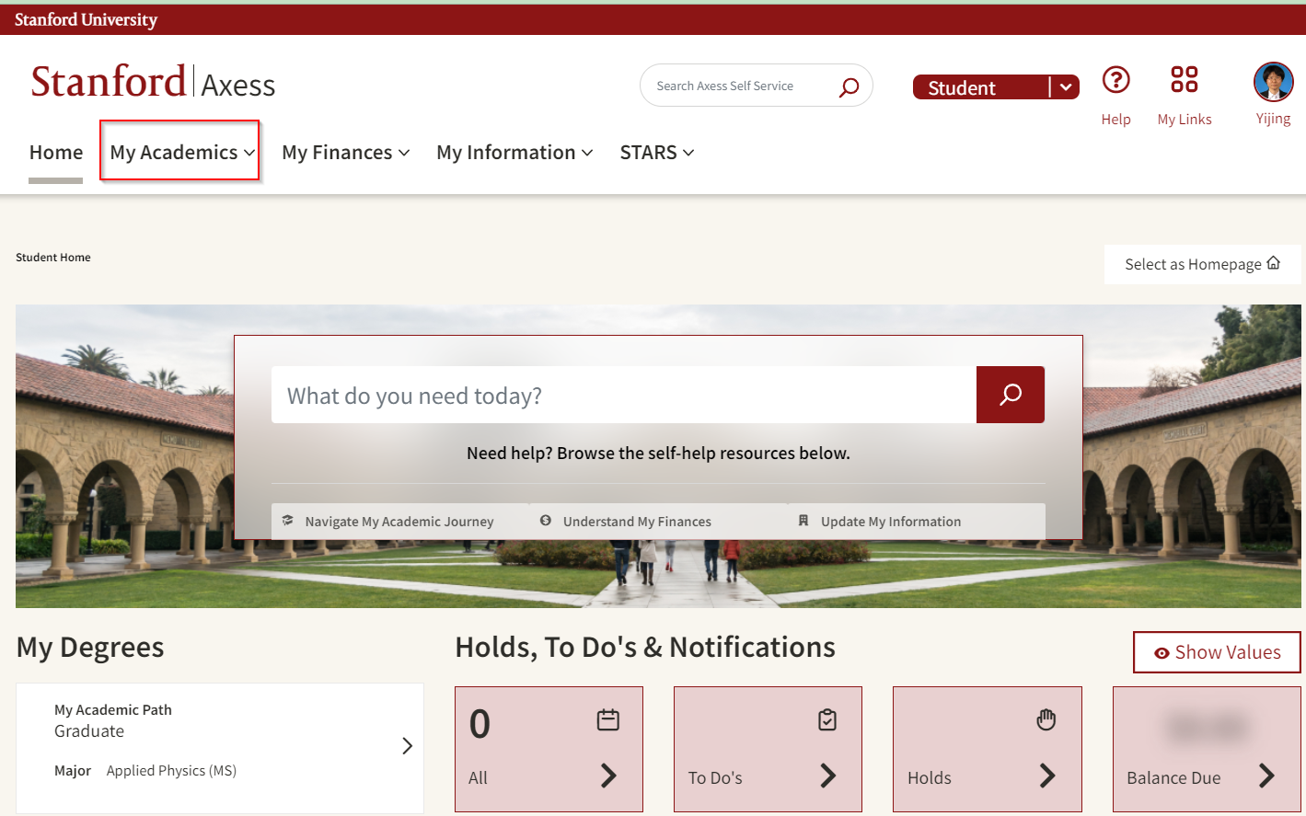
- Select: My Academics>Petitions & Forms>Postdoctoral Forms
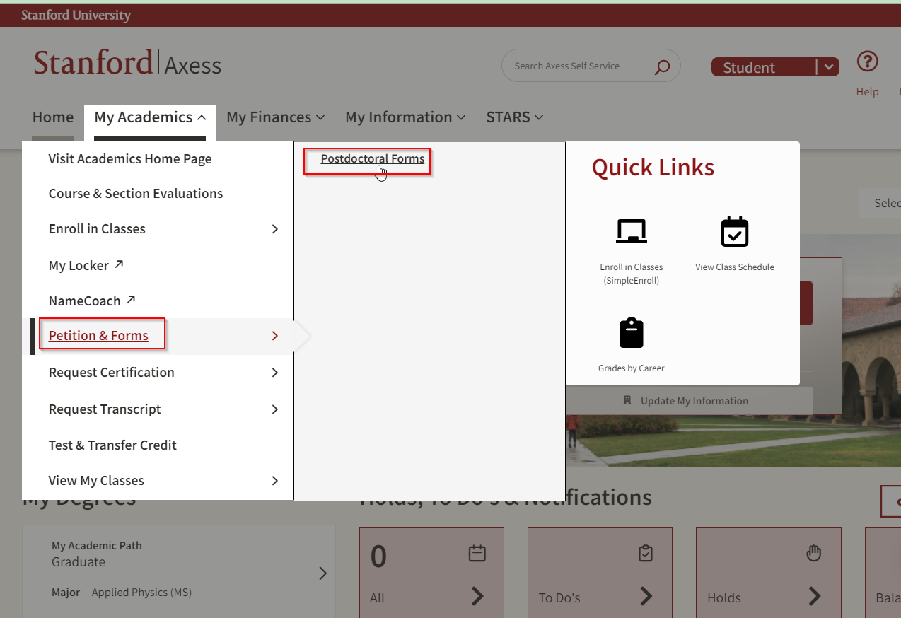
- Select: Create LOA Request
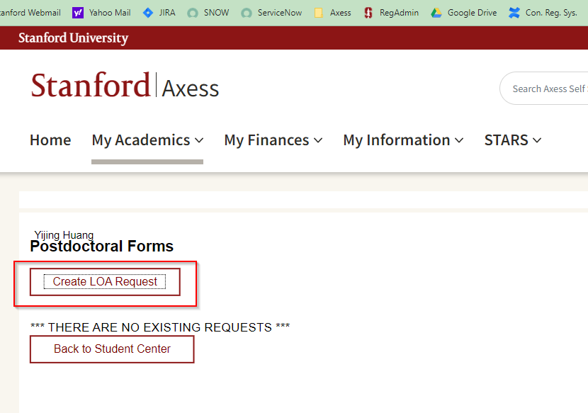
- This will open a LOA form with the current appointment
